ONLINE VOTING SYST

CLASS DIAGRAM

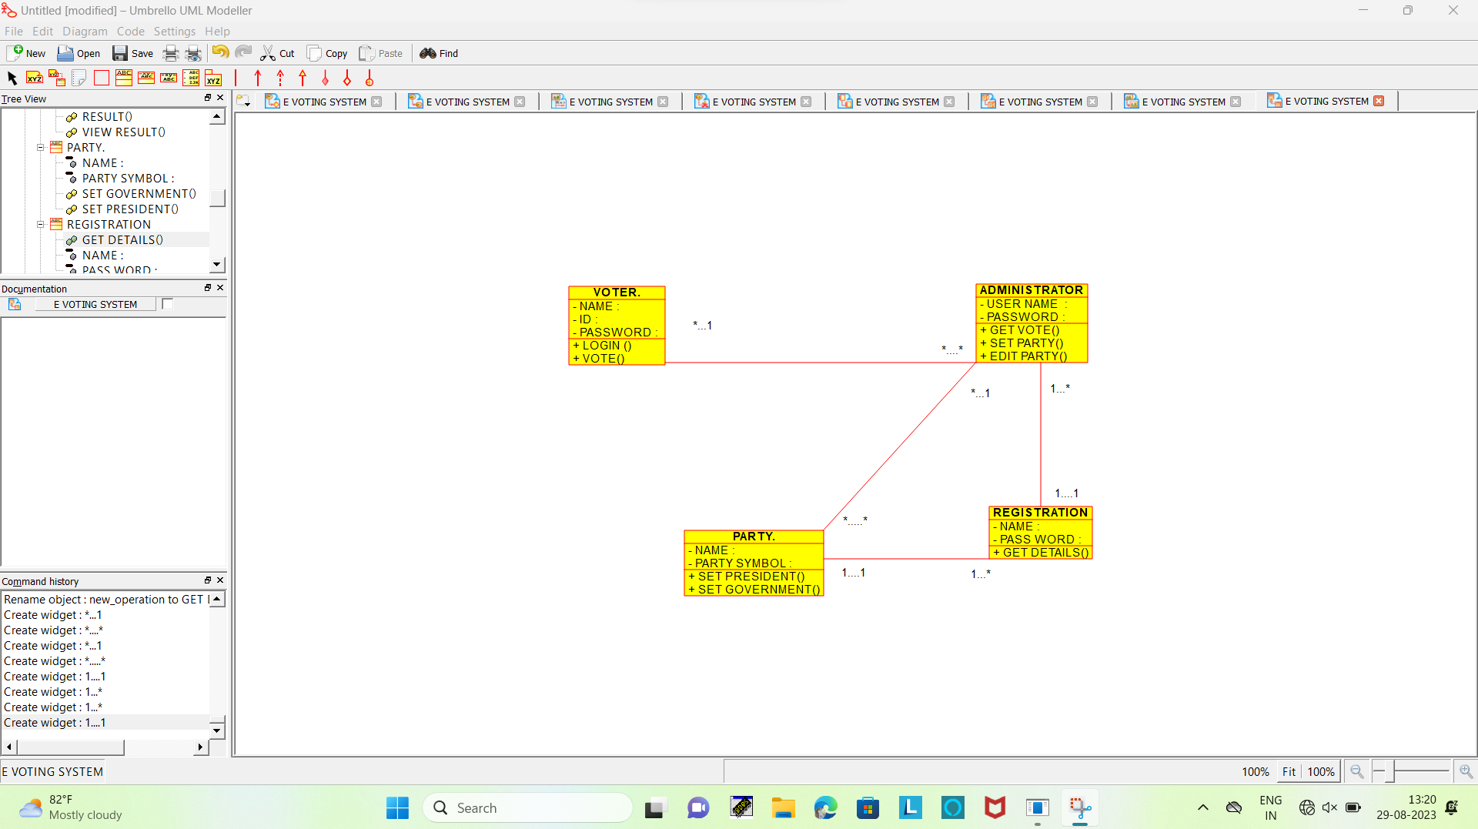

ACTIVITY DIAGRAM

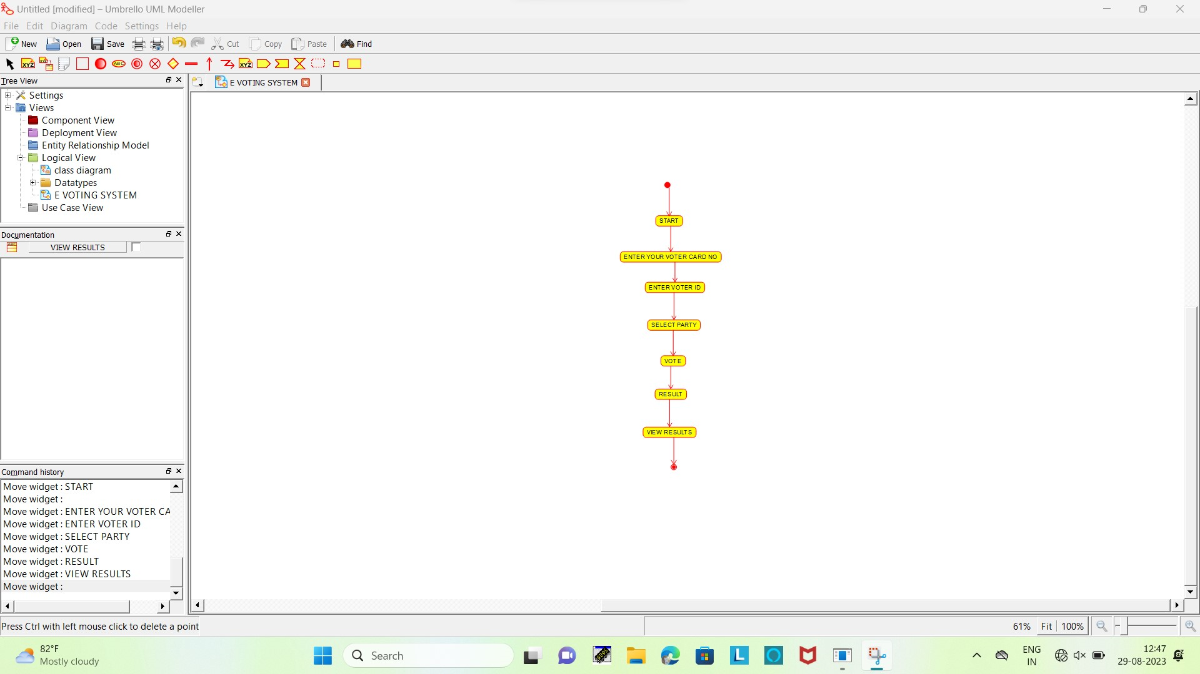

SEQUENCE DIAGRAM

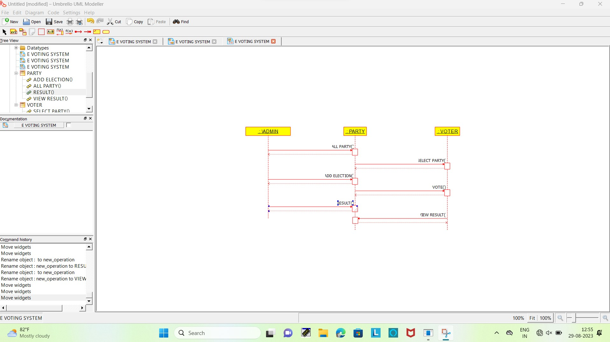

USE CASE DIAGRAM

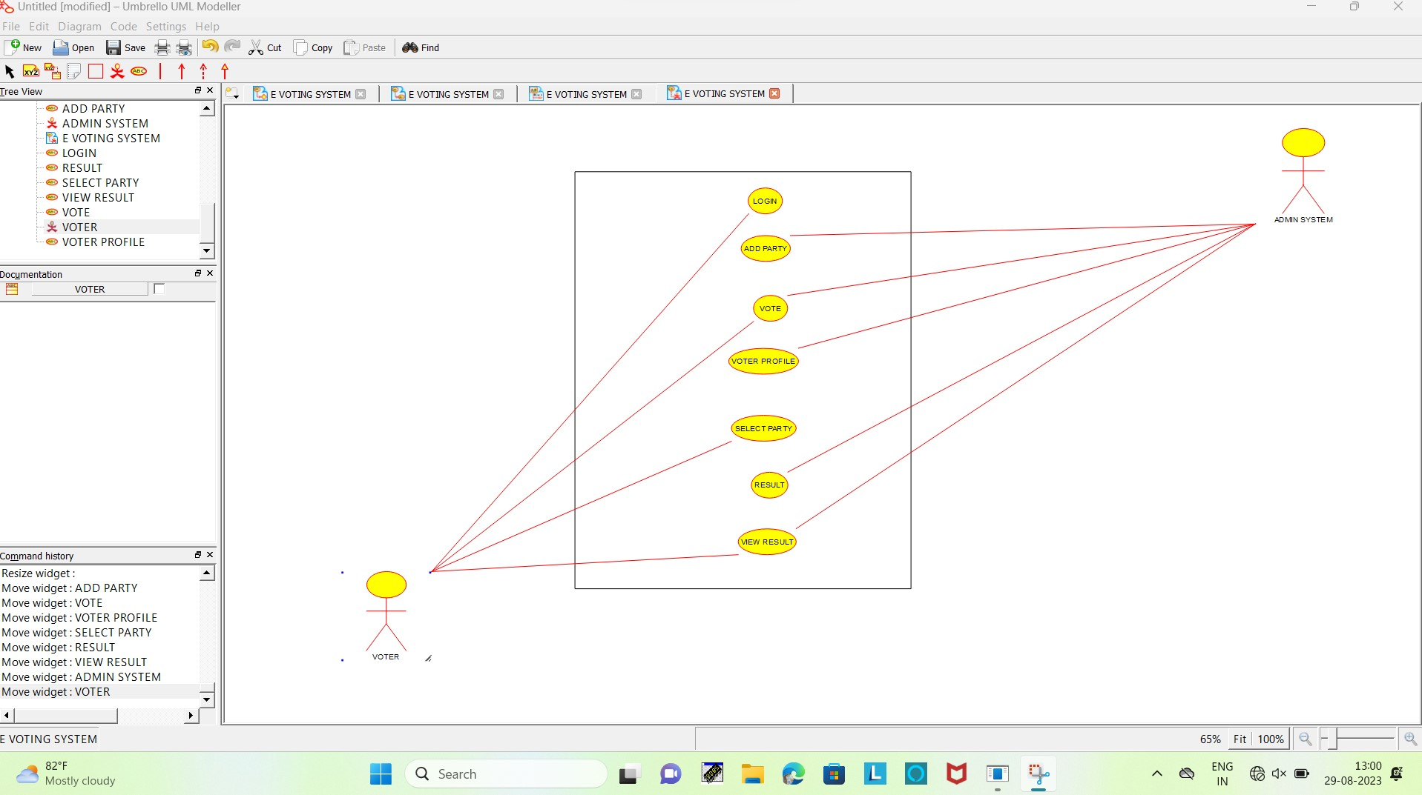

COMPONENT DIAGRAM

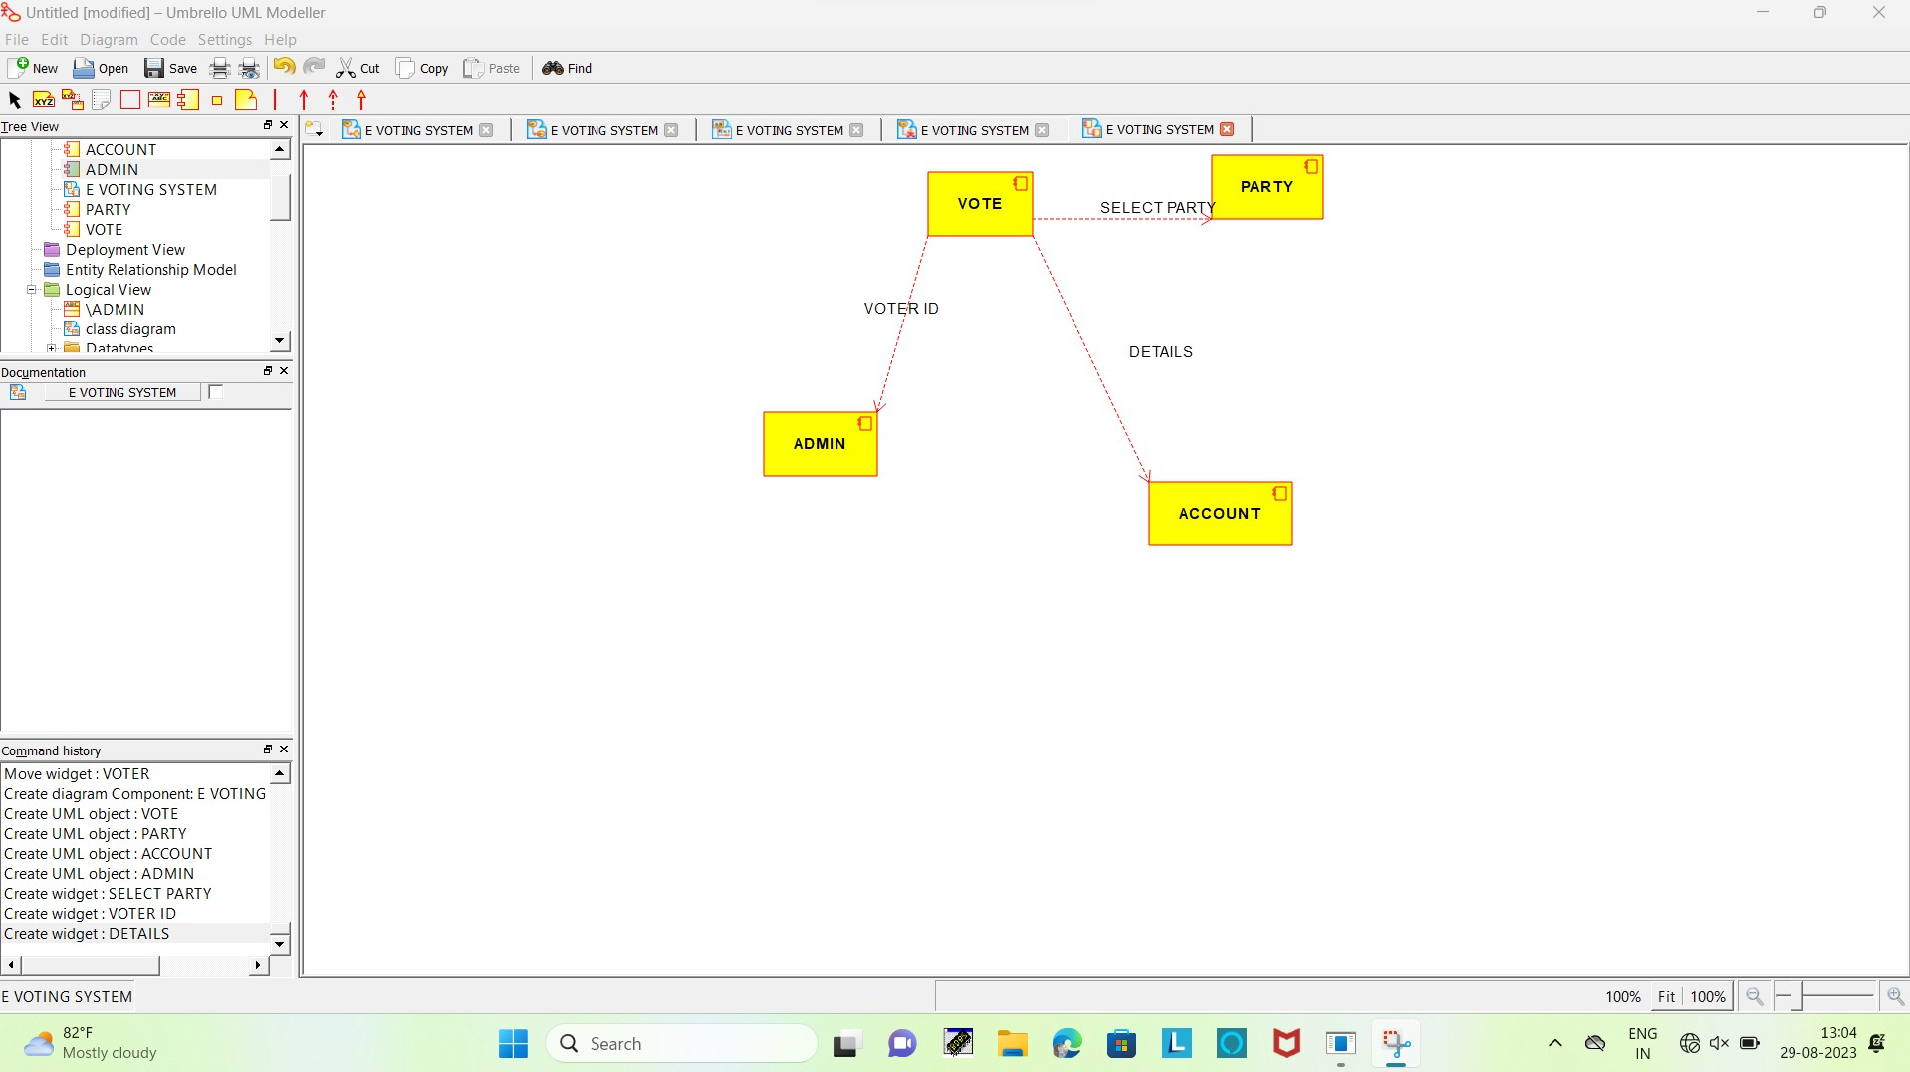

DEPLOYMENT DIAGRAM

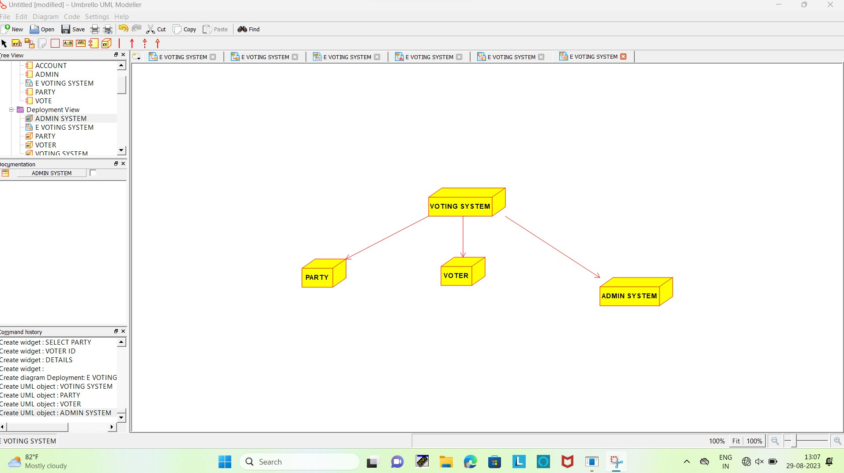

COLLABORATION DIAGRAM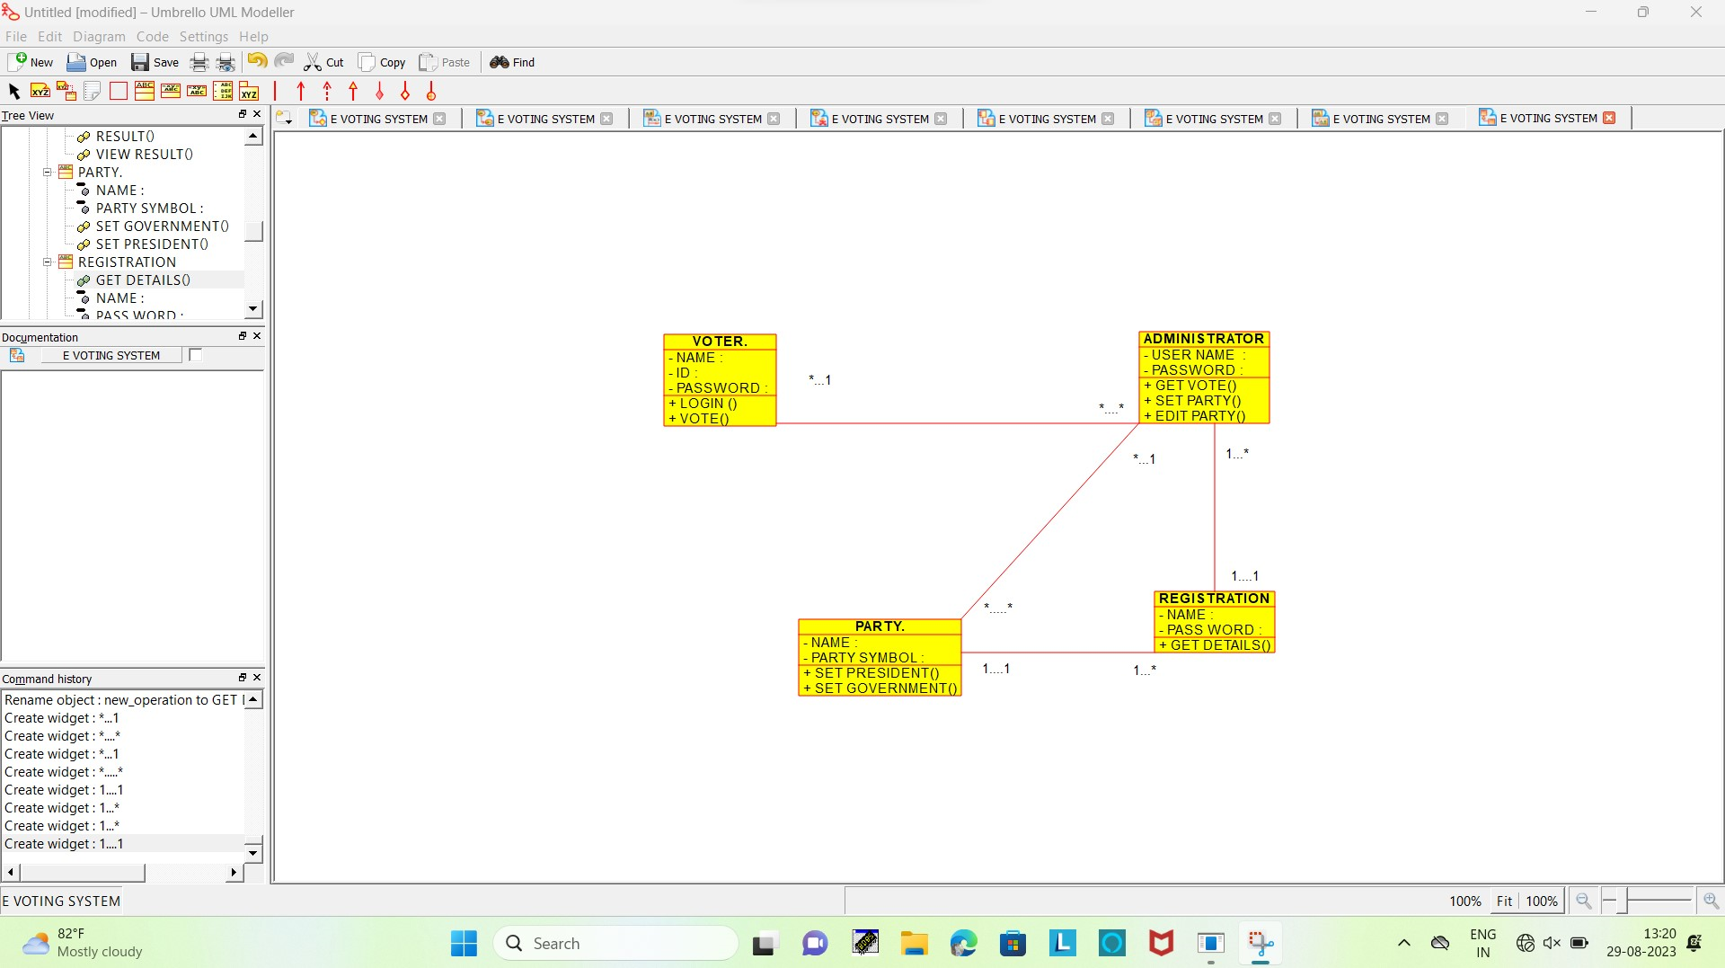

STATE CHART DIAGRAM

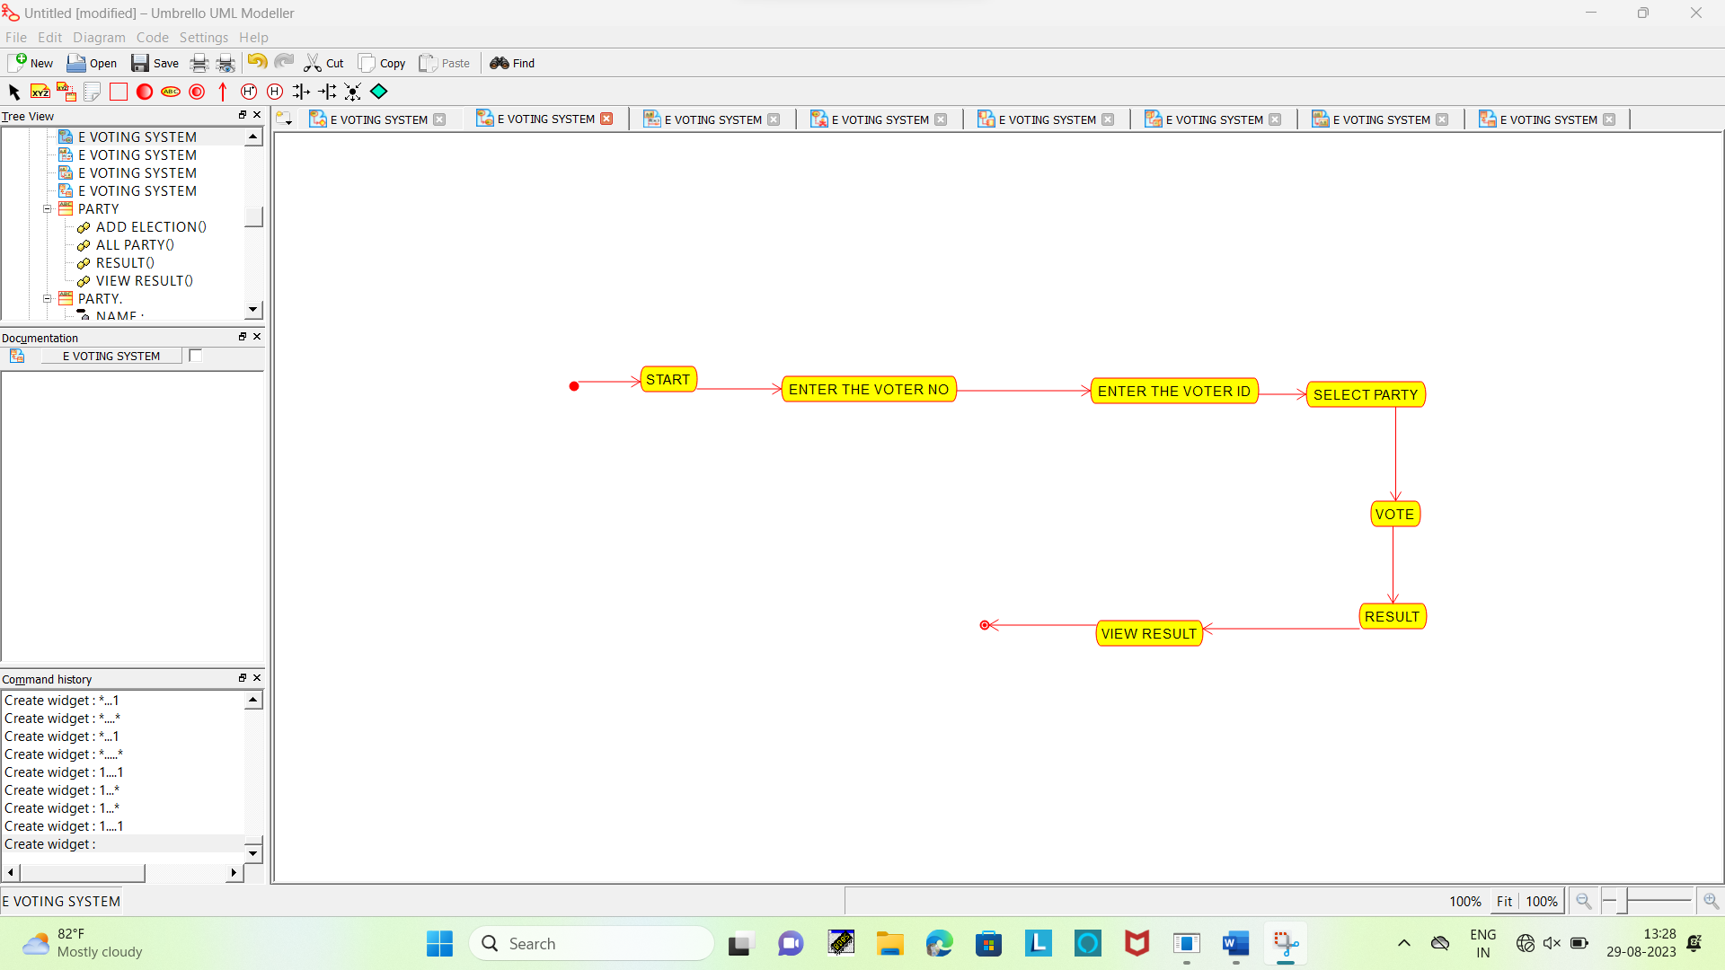

SUPER MARKET MANEGEMENT SYSTEM

COMPONENT DIAGRAM

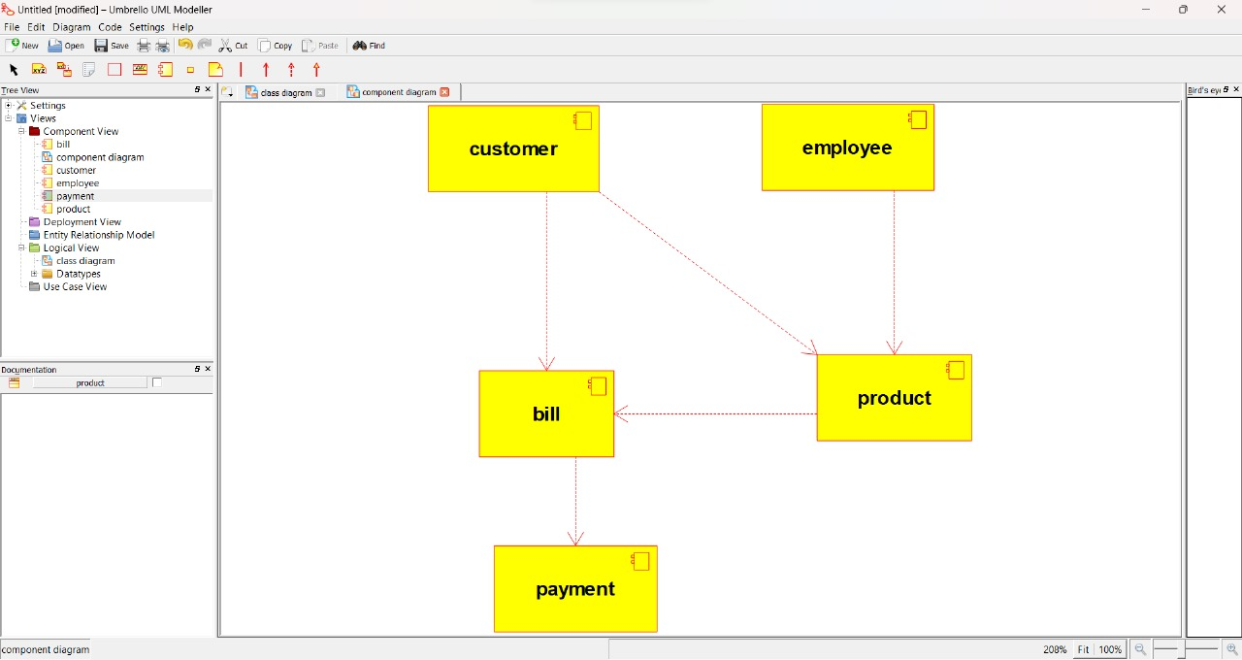

COLLABORATION DIAGRAM

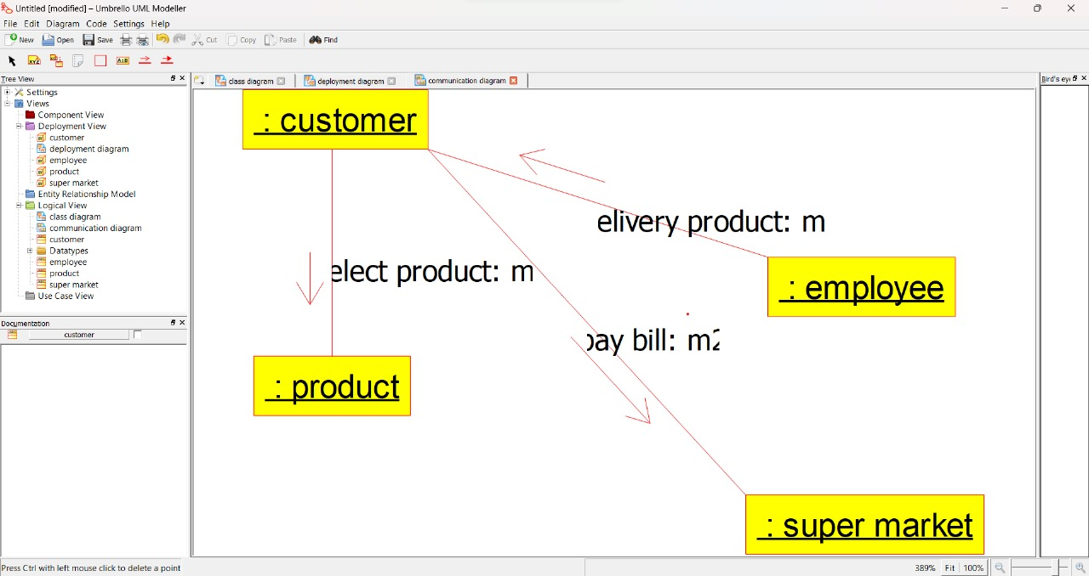

DEPLOYMENT DIAGRAM

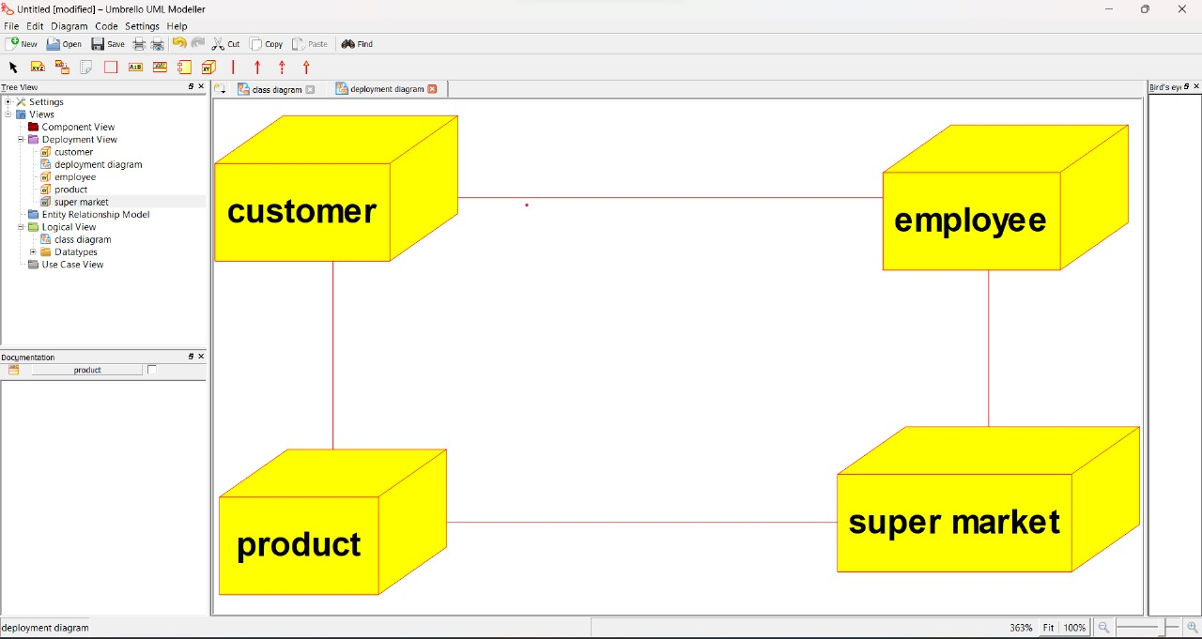

ACTIVITY DIAGRAM

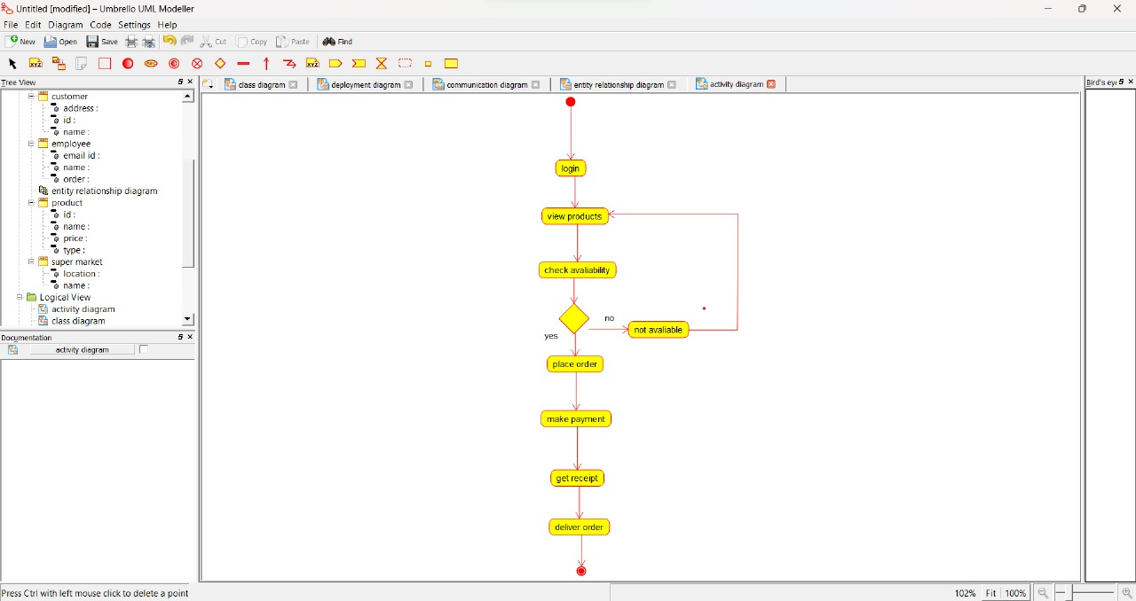

CLASS DIAGRAM

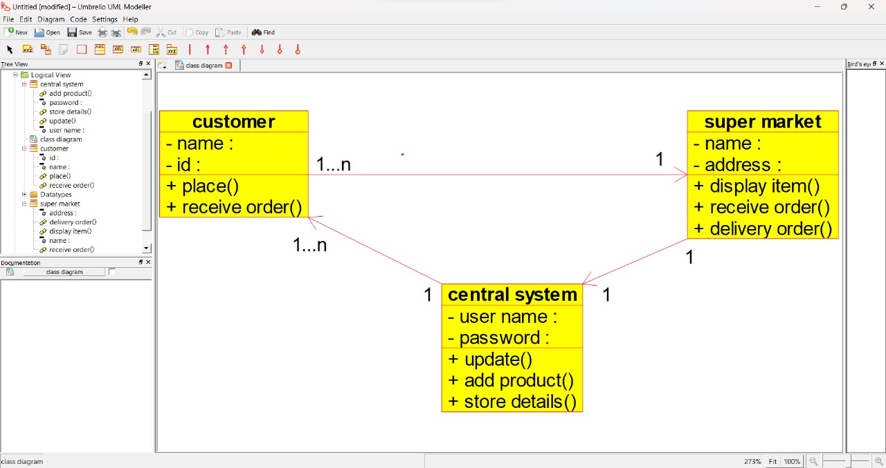

STATE CHART DIAGRAM

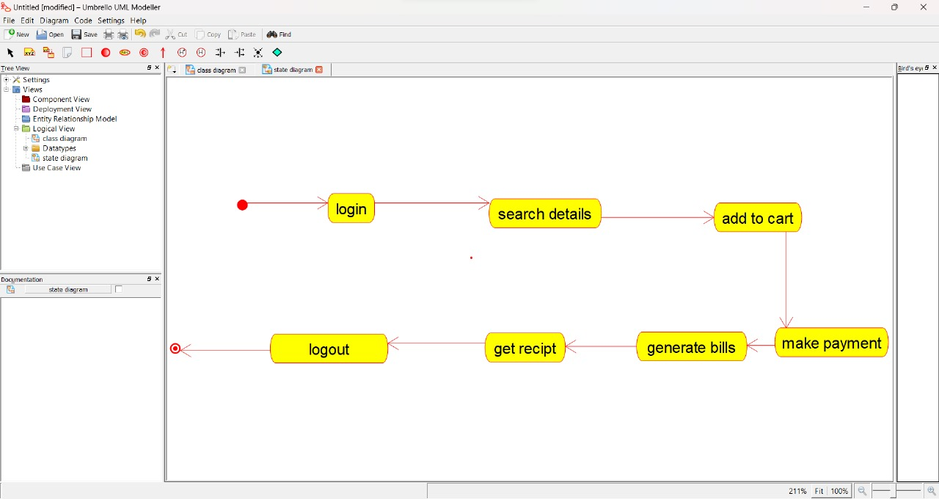

USE CASE DIAGRAM

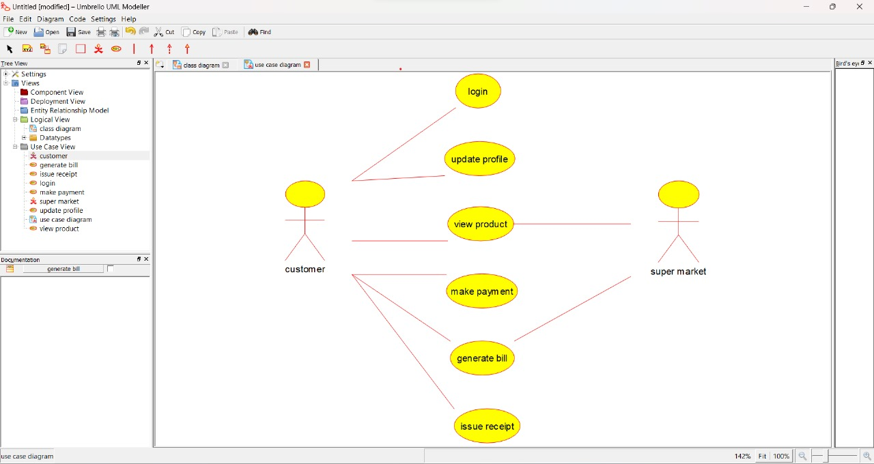

SEQUENCE DIAGRAM

